Africa
By Janice Lamattina

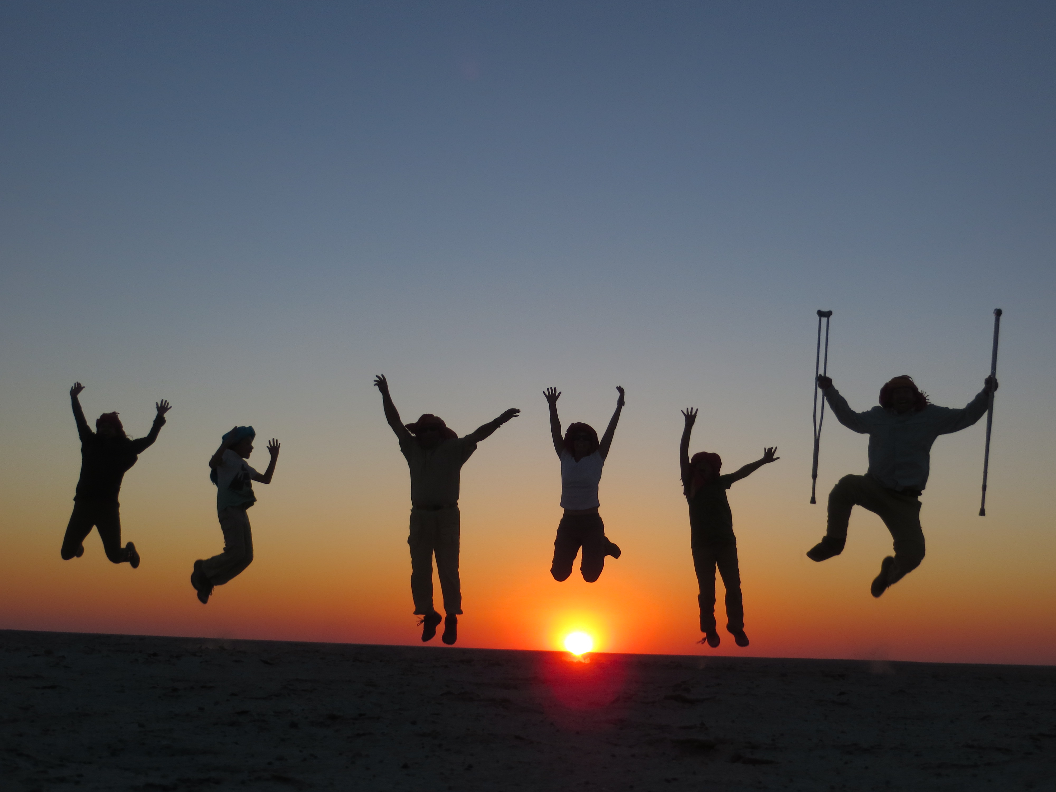

We have a tradition of taking each of our grandchildren on a "special trip with Poppy & JJ”, usually when they are about 10 years old.

When it was time for our twins'—Lily and Spencer—trip, the destination was Botswana! EVERYONE was excited anticipating our first safari! Mom and Dad were coming along as well—no one wanted to miss this big adventure. Would we really see lions? Elephants?? Giraffes??? Leopards???? What would it be like sleeping in a tent in the African delta with baboons right outside the door?

Yes! We did see all the wildlife and shared many special moments with Lily and Spencer. The image of their little faces, mouths agape, wide-eyed but fearlessly starring at lions only a few feet from our jeep ... or their 10 year old selves trying to sit so very still in hopes that a meerkat might actually climb up onto their head ... or watching the look of sadness and confusion on Spencer's face as he saw a homeless boy in Soweto, younger than himself, trying to start a fire to keep warm. These are only a few of the vivid memories that live in our hearts still.

But perhaps the most special shared moment was near the end of the trip, the last night, in fact.

Over the two weeks, the family had stayed in three camps, each with unique wildlife and experiences. The last camp was to be out on the flat saltpans. Not much wildlife or vegetation. I worried: how could this possibly measure up to the preceding exotic days?

What little I knew.

Late one afternoon, our guide herded us to our jeep saying we were going to experience sundown on the Makgadikgadi saltpans in the middle of the Kalahari. There, where the barren flatness stretches 360 degrees to the horizon, we were taught to wrap on our own colorful kikois, Lawrence of Arabia style. Describing how the San Bushmen must find their way across this land in blinding sand storms, he tested our ability to walk a straight line ... blind folded. And then, thrilling the kids, he said we would each drive our own 4x4 in a caravan across the desert. Have you ever seen the look on the face of a 10-year-old boy as he climbs on top of a huge 4x4, turban flapping in the wind, as he feels the engine vibrate and roar when he touches the handles?

We rode across the flats into the setting sun: our little family caravan. As dark descended, we spotted a campfire on the horizon. When we approached, to our amazement, the camp staff had - incredulously - set up a gorgeous elegant dining table miles from camp in the middle of, literally, nowhere. Complete with white linens and crystal stemware, we dined by candlelight as the stars came out. We watched the light flicker across Spencer & Lily's happy and tired faces as our guide entertained them with magic tricks. Nearly time to head back to camp after this last, special, day of a "special trip."

But wait. The guide begins to describe the weathered ancient skeleton of a rare black rhino that the camp's founder had discovered many years before. "It is quite special and very nearby. You really must see it. "

And so we followed our guide ... away from the light of the campfire ... out into the darkness. Nothing. We walked. Nothing. But then, as we began to see some sort of shape emerge from the darkness, we mumbled, "I see something." "That must be it." "Over there.” We walked a bit further into the night and saw six beds lined up on the sand under the stars. Just beds. Nothing more. But proper beds: with frames, on legs, mattresses, down comforters and feather pillows. "You may sleep here," our guide said pointing. "There is no wildlife. There is nothing here. You are totally safe. It will just be you, your family, looking up at the night sky. The beds are facing east, so in the morning you will see the sun rise over your toes."

In shock, we stood silently in the dark. Over our shoulders, way in the distance and barely visible, was the campfire we had left behind.

And so our family took off our shoes and climbed into what may certainly be the warmest, coziest beds ever. We laid side by side, each bed only a couple feet from the next, overwhelmed and in awe; in awe of this incredible opportunity, the vastness of the black sky overhead, the quiet, the brilliance of the stars. For a while, we pointed out shooting stars to each other until finally we fell quiet too. Tired, yes. But realizing how tiny we were in the middle of this space in the Kalahari.

The next morning, with our unobstructed view to the horizon, we did see the sun rise over our toes, its light made more vivid and orange by the filtered dusty air of the desert. Slowly, one by one, we began to stir. The adults first, stretching as we looked around at the emptiness that we had not been able to fathom in last night's dark.

And then Lily and Spencer began to wake up. First, Lily—who is NOT a morning child! She climbed out of bed, wrapped herself warmly in the previous day's kikois and calmly walked the several hundred yards to the campfire and her awaiting breakfast. Spencer rolled over: looked at the sun, looked around at all his family, studied his surroundings and plaintively said, "I DONT WANT TO LEAVE AFRICA!!!"

We all shared his feeling of not wanting the time together to end. Three generations had shared and discovering together, experiencing once-in-a-lifetime moments. Our hearts and minds had been filled with unimagined memories.

I shared Spencer's 10-year-old angst: I DIDN'T WANT TO LEAVE AFRICA either!!

Poppy unexpectedly passed away on Easter Sunday. This insightful account of a special place, a special time, and a special moment will serve as a wonderful memory of the unique and loving bond Larry, JJ and their grandchildren shared.

